Leaf Decomposition Study — Results Report
Boye (Urban) & Kinzig (Agricultural) Streams | March 2025
Based on Schreiner et al. (2023) — Environmental Toxicology and Chemistry

1. Study Overview
This report presents the results of a leaf litter bag decomposition field study conducted in March 2025 across two distinct stream catchments: the Boye Stream (urban/industrial catchment) and the Kinzig Stream (predominantly agricultural/rural catchment). Alder leaf litter (Alnus glutinosa) was deployed in fine mesh (0.5 mm) and coarse mesh (10 mm) bags for approximately 15 days. Decomposition rates were quantified as Decomposed Substrate Mass (DSM), normalised by degree-days following Schreiner et al. (2023).

2. Study Design Summary
Parameter | Boye Stream | Kinzig Stream
Catchment type | Urban / Industrial | Agricultural / Rural
No. of sites | 23 sites | 21 sites
Deployment | 4–11 March 2025 | 4–11 March 2025
Incubation (mean) | ~15 days | ~15–19 days
Bag types | Fine (0.5 mm) + Coarse (10 mm) | Fine (0.5 mm) + Coarse (10 mm)
Replicates | 3 per site per bag type | 3 per site per bag type
Leaf species | Alder (Alnus glutinosa) | Alder (Alnus glutinosa)
Mean conductivity | 854.8 µS/cm | 330.7 µS/cm
Mean % urban | 41.5 % | 3.0 %
Mean % agricultural | 39.8 % | 52.1 %
Total bags deployed | 138 bags (23×6) | 126 bags (21×6)

Table 1. Summary of study design and catchment characteristics.

3. DSM Computation Method
The Decomposed Substrate Mass (DSM) was calculated per leaf bag as:
DSM = [(AFDM_start − AFDM_end) / AFDM_start] ÷ degree-days × 100
Where AFDM_start was derived from transport control corrections; AFDM_end = mass at 60°C − mass at 500°C; degree-days = mean water temperature × incubation days. Leaf disk corrections: 12 mg per disk removed. Negative DSM values excluded.

4. Results

4.1 Overall Decomposition Rates
Leaf decomposition differed substantially between bag types and streams. Coarse mesh bags decomposed at approximately 3× the rate of fine mesh bags in both streams, confirming significant invertebrate shredder contributions. Boye showed higher absolute DSM values than Kinzig, consistent with its elevated nutrient loading.

Stream | Bag Type | n bags | Mean DSM | SD | Min DSM | Max DSM
Boye | Fine mesh | 64 | 0.1730 | 0.0349 | 0.0824 | 0.2718
Boye | Coarse mesh | 68 | 0.5258 | 0.2054 | 0.0547 | 0.9496
Kinzig | Fine mesh | 58 | 0.0996 | 0.0348 | 0.0314 | 0.1973
Kinzig | Coarse mesh | 53 | 0.3600 | 0.1354 | 0.1375 | 0.6667

Table 2. DSM summary statistics by stream and bag type. DSM units = % mass loss per degree-day.

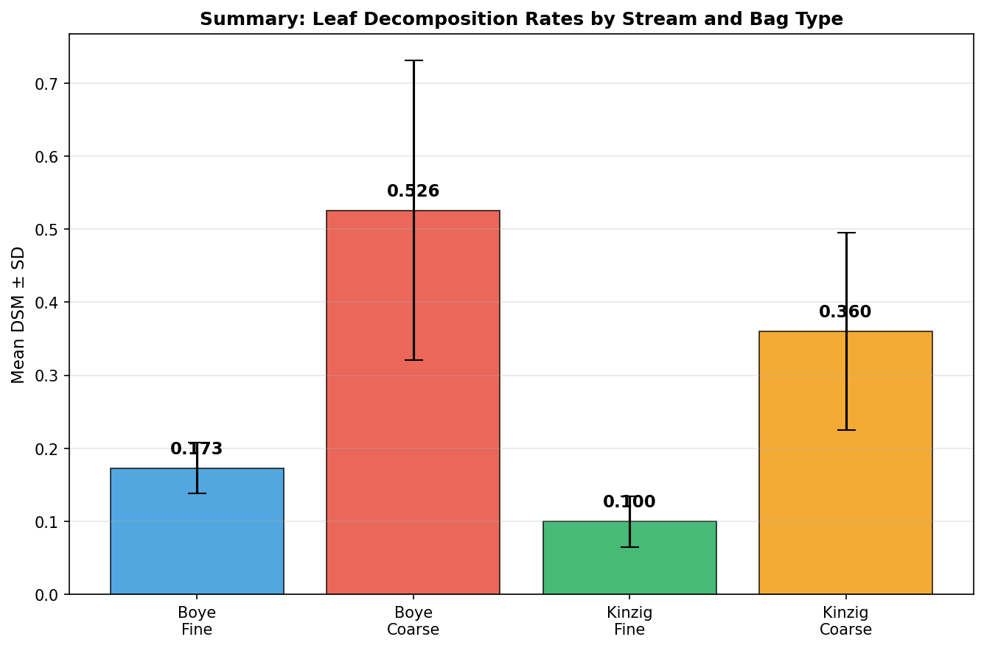
Figure 1. Mean DSM (± SD) by stream and bag type. Boye exhibits consistently higher DSM values in both mesh types.

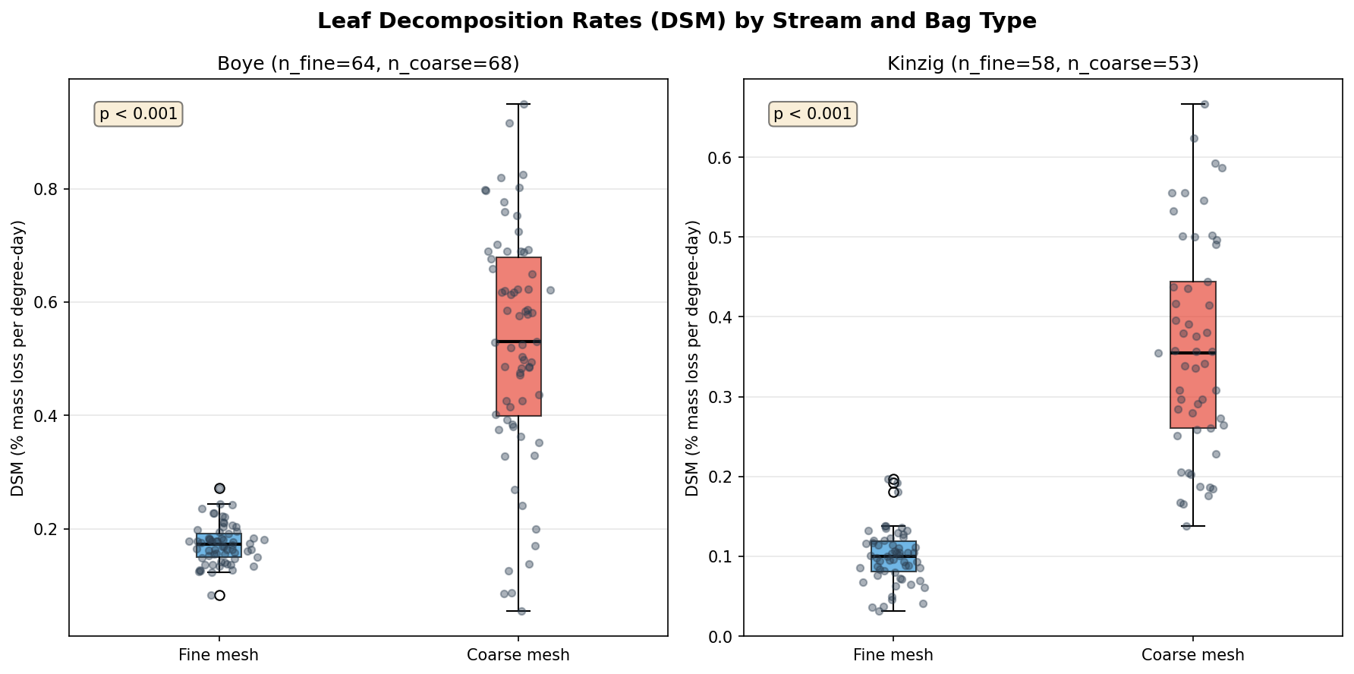
Figure 2. Boxplot of individual bag DSM values. Coarse mesh rates significantly exceed fine mesh in both streams (p < 0.001).

4.2 Site-Level Variation
Site-level DSM values showed substantial spatial variation within both catchments, reflecting differences in land use intensity, water chemistry, and physical habitat.

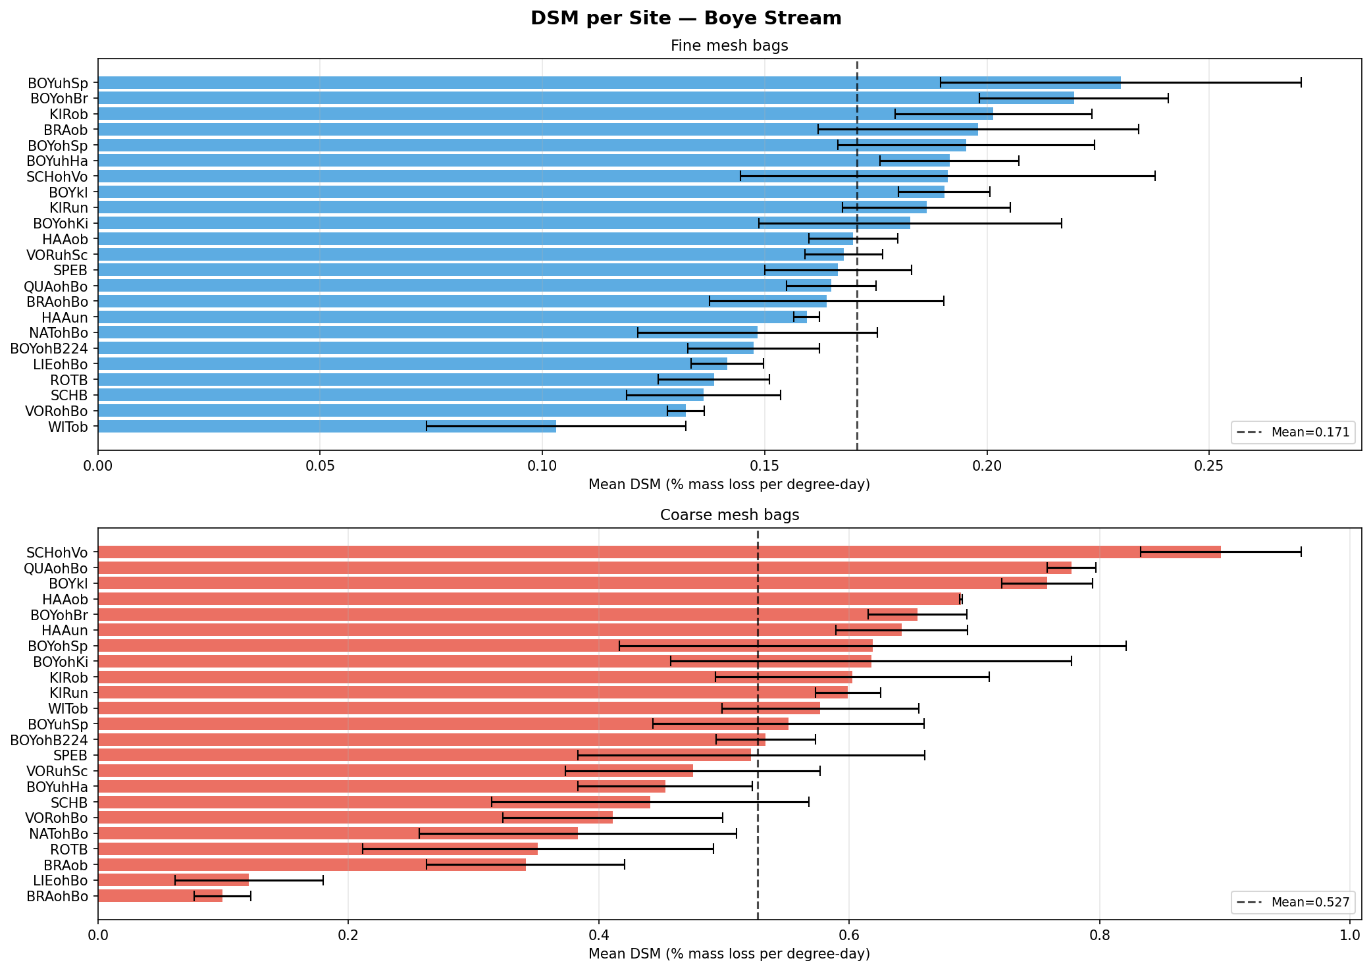
Figure 3. Mean DSM per site — Boye Stream. Error bars = ± 1 SD.

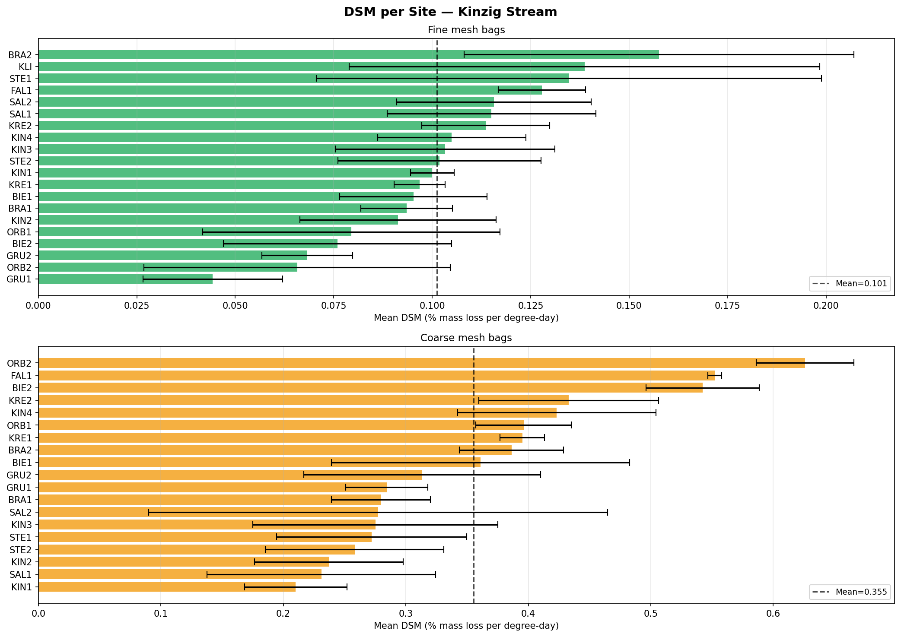
Figure 4. Mean DSM per site — Kinzig Stream.

4.3 Hypothesis Testing — Boye Stream
Boye is characterised by high conductivity (854.8 µS/cm), elevated metal contamination, and predominantly urban land use (41.5 % mean).

H1: Higher conductivity negatively associated with fine mesh DSM
Result: SUPPORTED (r = −0.459, p = 0.028). A significant negative correlation was found between conductivity and fine mesh DSM. The ionic load in the urbanised Boye catchment partially suppresses microbial leaf decomposition activity. No significant relationship was found for coarse mesh (r = −0.267, p = 0.243), suggesting macrofaunal shredders are less sensitive to ionic stress in this range.
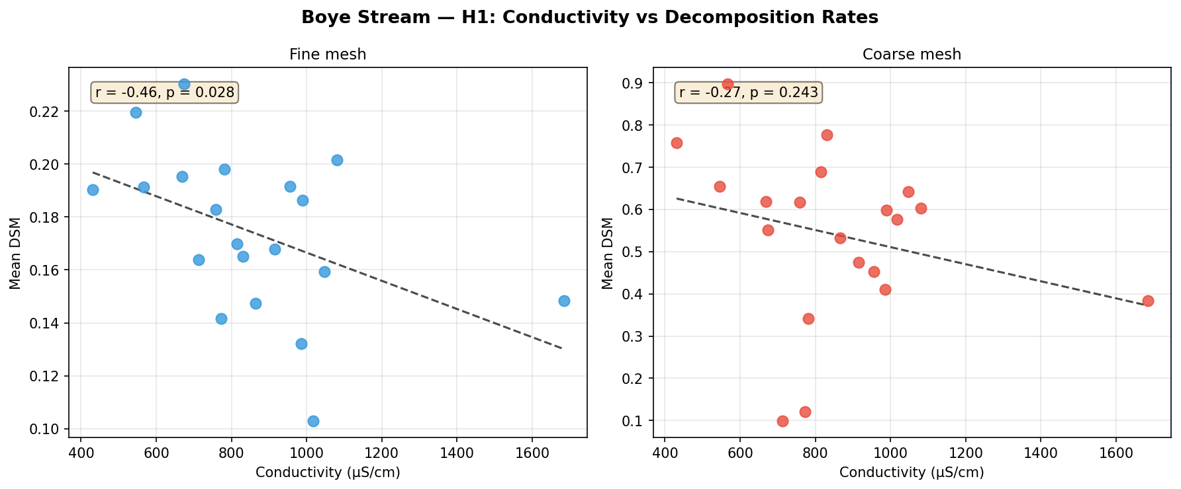
Figure 5. Conductivity vs fine and coarse mesh DSM — Boye Stream. Significant negative trend for fine mesh only.

H2: Higher urban land use reduces leaf decomposition rates
Result: NOT SUPPORTED (r = −0.265, p = 0.247). Urban land use percentage was not significantly correlated with fine or coarse mesh DSM. High variability in urban percentage and limited site-level variation may have reduced statistical power. The negative directional trend is consistent with the hypothesis, however.
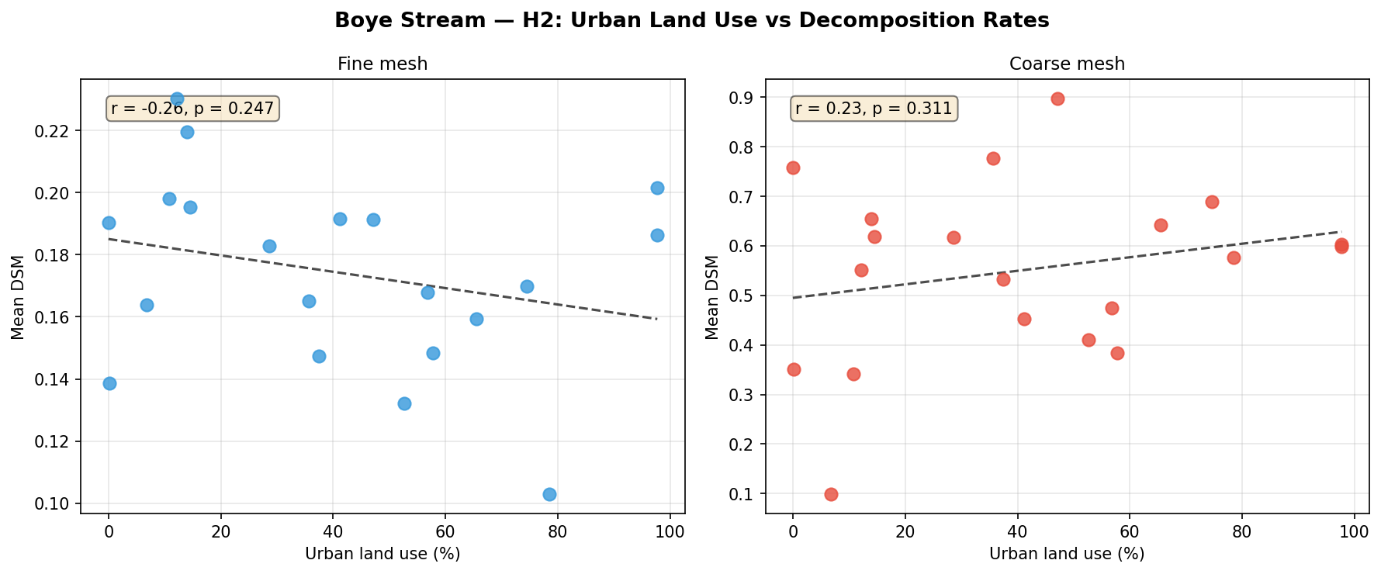
Figure 6. Urban land use (%) vs fine and coarse mesh DSM — Boye Stream.

H3: Gammarus shredders drive higher coarse mesh DSM
Result: PARTIALLY SUPPORTED. While log-Gammarus vs coarse DSM correlation was not significant across sites (r = 0.075, p = 0.744), coarse mesh DSM was 3.04× higher than fine mesh (t = 13.95, p < 0.001), confirming substantial shredder-driven decomposition. Site-level variation in Gammarus abundance did not predict within-stream differences in this snapshot.
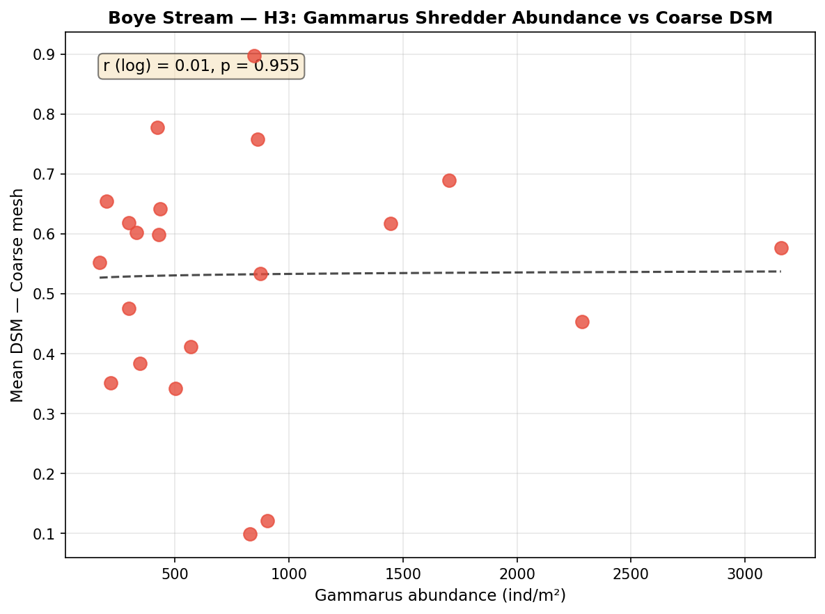
Figure 7. Log-Gammarus abundance vs coarse mesh DSM — Boye Stream.

H4: Higher Zn and Cu concentrations reduce fine mesh DSM
Result: NOT SUPPORTED (Zn: r = −0.025, p = 0.919; Cu: r = −0.298, p = 0.175). Metal concentrations in the Boye were low (mean Zn: 2.82 µg/L; mean Cu: 0.18 µg/L), likely below the functional toxicity thresholds for microbial decomposers, explaining the lack of a significant relationship.
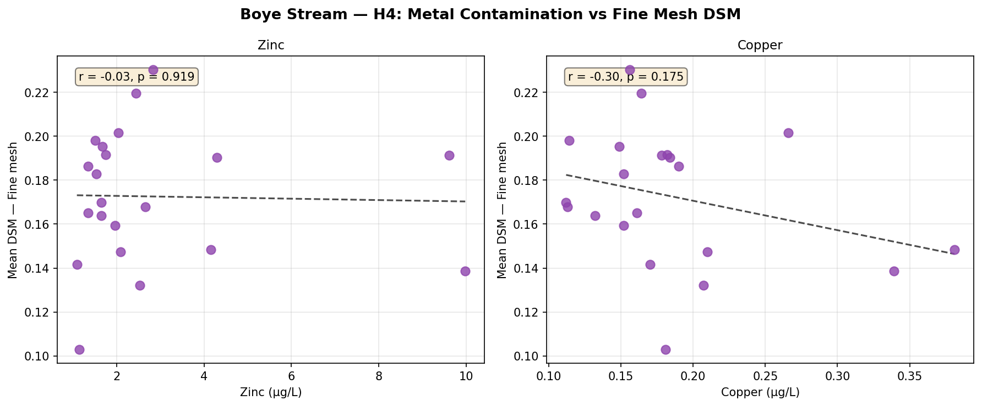
Figure 8. Zn and Cu concentration vs fine mesh DSM — Boye Stream.

4.4 Hypothesis Testing — Kinzig Stream
Kinzig is predominantly agricultural (52.1 % catchment area) with lower conductivity (330.7 µS/cm mean) and lower metal concentrations than Boye.

H1: Higher nitrate concentrations positively associated with fine mesh DSM
Result: NOT SUPPORTED (r = +0.344, p = 0.120). A positive trend was observed but did not reach significance. The limited range of nitrate concentrations within Kinzig (3.3–13.4 mg/L) may explain the weak effect. Total nitrogen showed a similar non-significant trend (r = 0.342, p = 0.123).
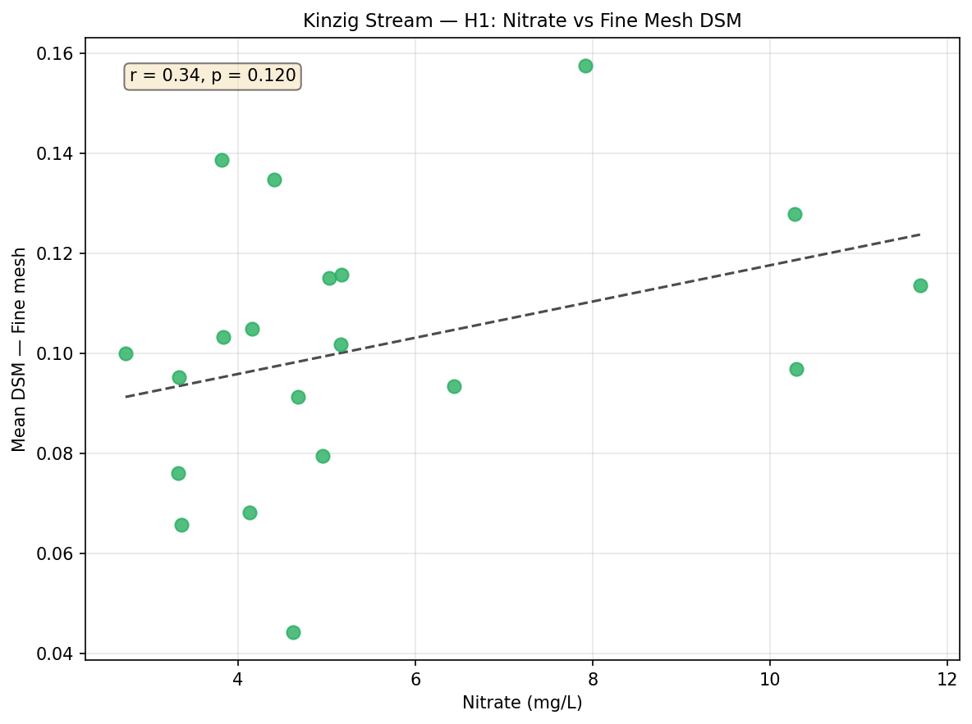
Figure 9. Nitrate vs fine mesh DSM — Kinzig Stream.

H2: Higher agricultural land use positively associated with DSM
Result: STRONGLY SUPPORTED (r = +0.738, p = 0.0002). Agricultural land use was the strongest predictor found in this study. Sites with higher agricultural catchment proportions showed markedly higher microbial DSM, reflecting elevated nutrient loading (N, P) stimulating fungal and bacterial activity. Coarse mesh was not significantly related (r = −0.359, p = 0.112).
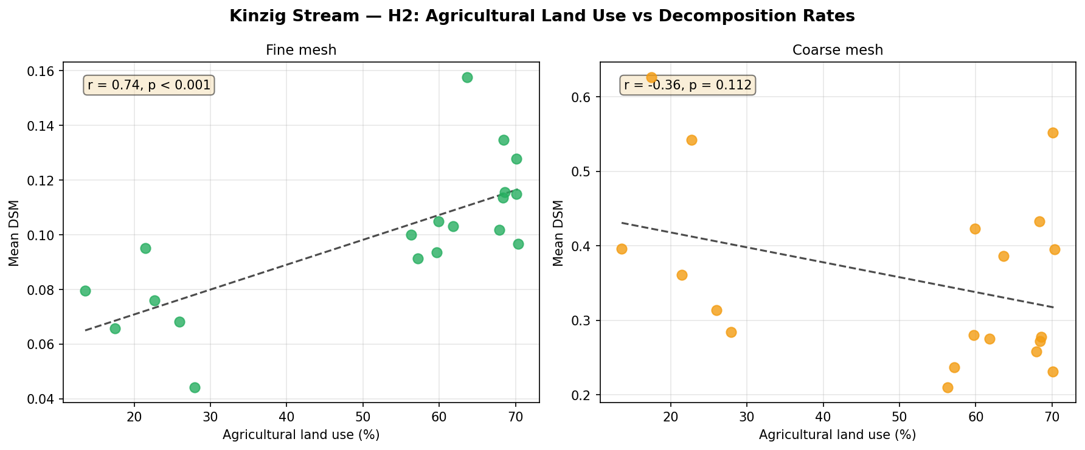
Figure 10. Agricultural land use (%) vs DSM — Kinzig Stream. Strong positive relationship for fine mesh (p = 0.0002).

H3: Coarse mesh DSM significantly higher than fine mesh (shredder effect)
Result: STRONGLY SUPPORTED (t = 13.60, p < 0.001). Coarse mesh DSM was 3.62× higher than fine mesh (0.360 vs 0.100 %/DD). Invertebrate shredders play a critical role in accelerating organic matter breakdown in this stream. The Kinzig showed greater variability in the coarse-to-fine ratio than Boye, suggesting site-specific differences in shredder communities.
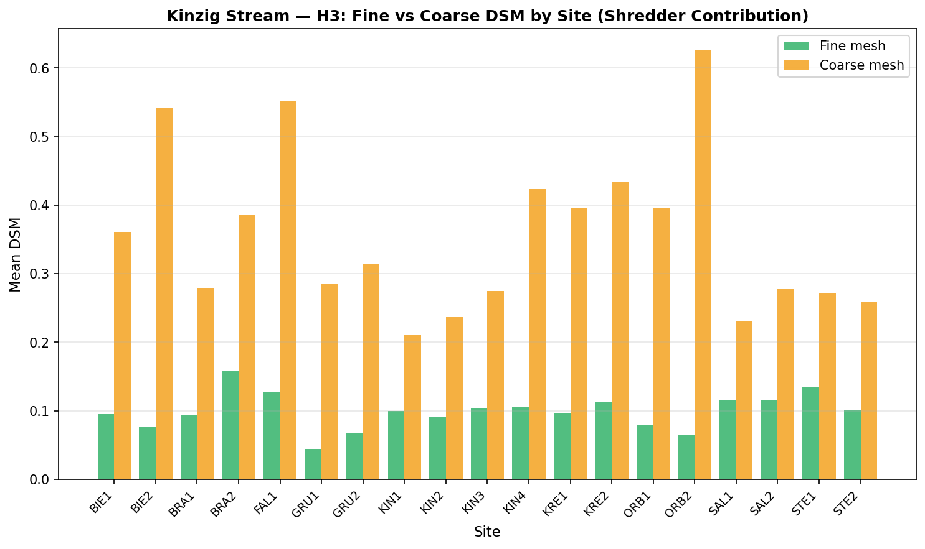
Figure 11. Fine vs coarse mesh DSM per site — Kinzig Stream. Coarse consistently exceeds fine at all sites.

H4: Higher conductivity positively associated with decomposition rates
Result: NOT SUPPORTED (r = +0.202, p = 0.389). Conductivity was not a significant predictor of decomposition in Kinzig. Agricultural land use (H2) was the more precise driver of decomposition rates, and conductivity co-varies with nutrient loading but the direct ionic effect is not significant in this data set.
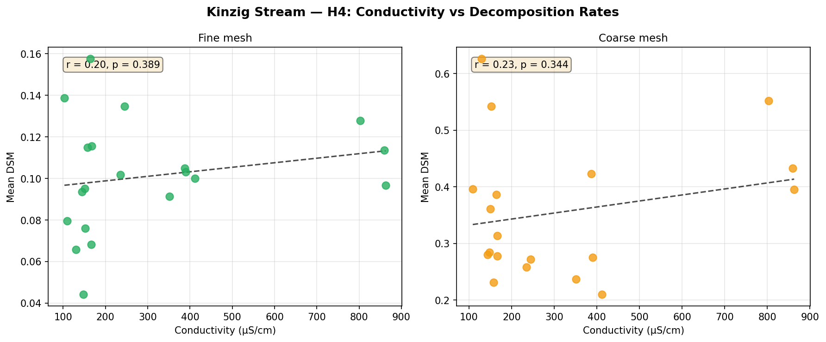
Figure 12. Conductivity vs DSM — Kinzig Stream.

4.5 Correlation Matrices
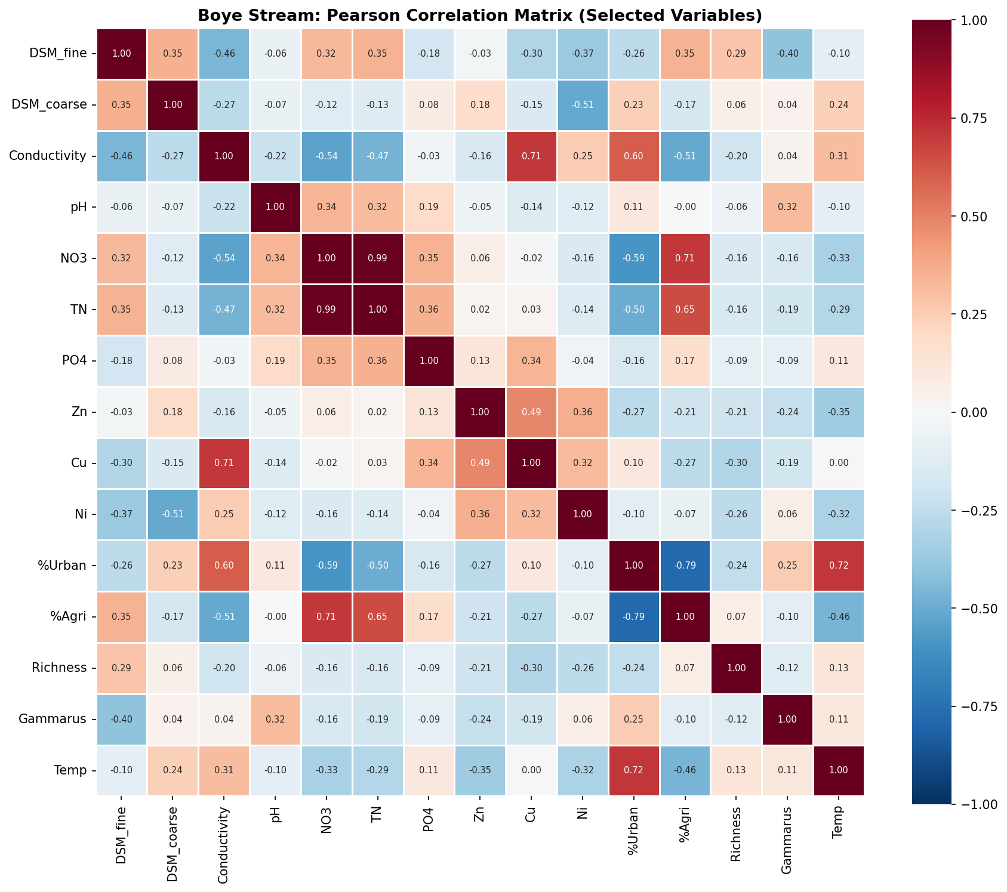
Figure 13. Pearson correlation matrix — Boye Stream. Blue = positive, red = negative. Strong co-linearity among metals and conductivity.

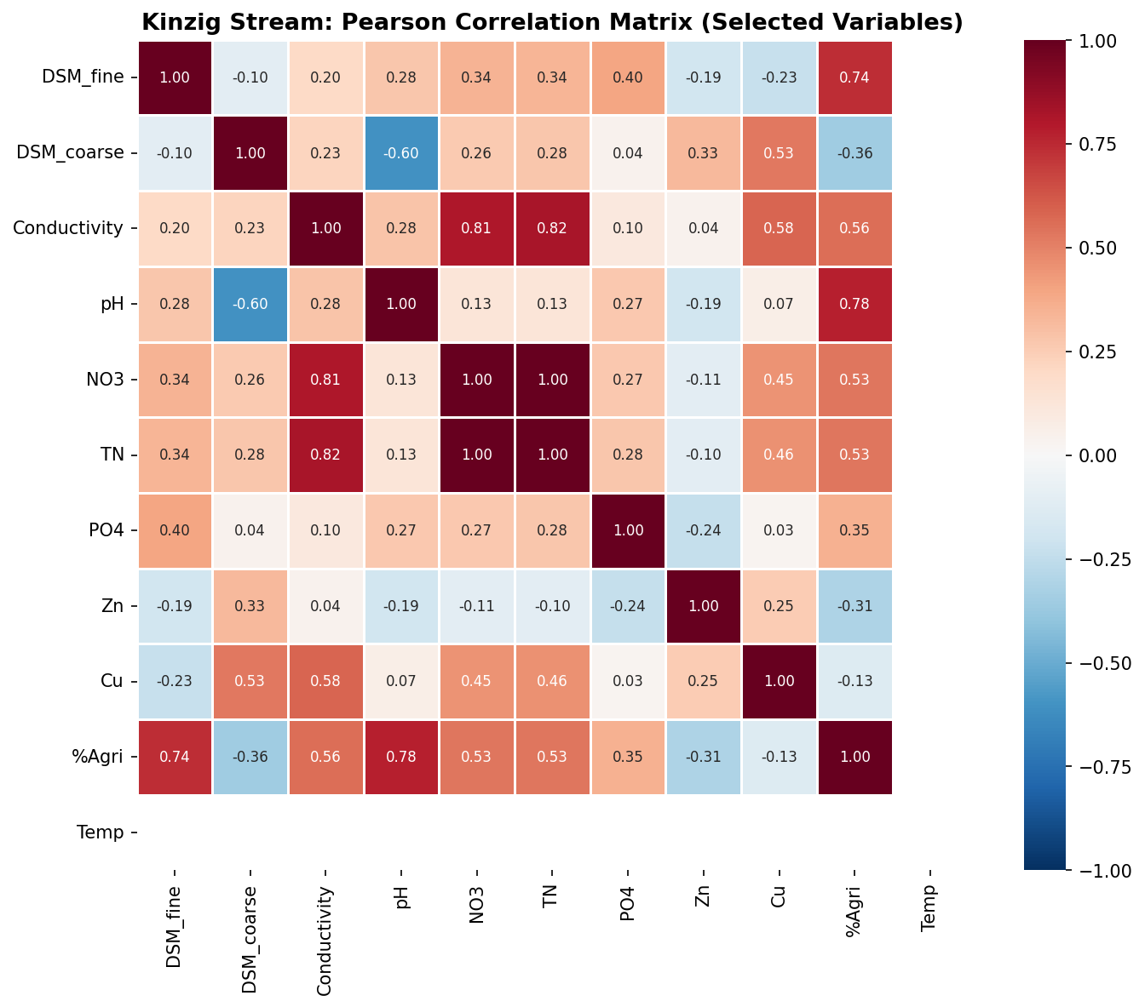
Figure 14. Pearson correlation matrix — Kinzig Stream. Strong positive associations among nutrient variables and % agricultural land use.

5. Hypothesis Summary Table

H | Stream | Hypothesis | Pearson r | p-value | Sig.? | Supported?
H1 | Boye | Conductivity vs Fine DSM | −0.459 | 0.028 | Yes * | Supported
H2 | Boye | %Urban vs Fine DSM | −0.265 | 0.247 | No | Not supported
H3 | Boye | Coarse vs Fine DSM (t-test) | n/a | < 0.001 | Yes *** | Partially
H4 | Boye | Zn vs Fine DSM | −0.025 | 0.919 | No | Not supported
H1 | Kinzig | Nitrate vs Fine DSM | +0.344 | 0.120 | No (trend) | Not significant
H2 | Kinzig | %Agricultural vs Fine DSM | +0.738 | 0.0002 | Yes *** | Strongly supported
H3 | Kinzig | Coarse vs Fine DSM (t-test) | n/a | < 0.001 | Yes *** | Strongly supported
H4 | Kinzig | Conductivity vs Fine DSM | +0.202 | 0.389 | No | Not supported

Table 3. Summary of all hypothesis test results. * p < 0.05, *** p < 0.001.

6. Conclusions
The Boye Stream was primarily constrained by ionic contamination (conductivity), where H1 was supported — elevated conductivity negatively predicted microbial decomposition rates. Metal contamination remained below functionally relevant thresholds and did not significantly inhibit decomposition.
The Kinzig Stream showed a strong and highly significant positive relationship between agricultural land use and microbial (fine mesh) decomposition, consistent with nutrient-stimulated fungal activity. This was the strongest relationship found in the entire study (r = 0.738, p = 0.0002).
In both catchments, invertebrate shredder activity (coarse–fine DSM ratio of 3.0–3.6×) was highly significant (p < 0.001), confirming the critical ecosystem service role of shredding macroinvertebrates in both impacted and agricultural stream systems.
These findings suggest that the key environmental driver of stream ecosystem function differs by catchment context: ionic and urban pollution constrains microbial decomposition in urbanised streams, while nutrient enrichment from agriculture enhances it — with implications for stream ecosystem services assessments under multiple stressor scenarios.

